Smart Medicine Box with Integrated Adherence Monitoring, Caregiver Alert System, and Modular Health Tracking

Authors

Abstract

Medication non-adherence remains one of the most persistent challenges in chronic disease management, contributing significantly to treatment failure, avoidable hospitalizations, and increased healthcare costs. Despite advances in digital health, most existing medication management systems either provide simple reminders or are too expensive for household use. In this work, we present the design and development of a low-cost smart medicine box that integrates adherence monitoring, caregiver alerting, and optional health tracking into a unified system.

The proposed device combines real-time medication reminders with compartment-level visual and auditory indicators, along with sensor-based verification of drawer access. A multimodal alert system notifies caregivers through mobile applications and SMS in the event of missed doses, low medication stock, or approaching expiry dates. The system further includes prescription digitization using optical character recognition to simplify initial setup and reduce user burden. In addition, the architecture supports modular integration of Bluetooth-enabled health monitoring devices, allowing time-synchronized correlation between medication adherence and physiological measurements such as blood pressure, oxygen saturation, and glucose levels.

A key design objective is affordability, with a bill of materials ranging from approximately 18 to 25 USD for the base model and 45 to 60 USD for the premium configuration. The system is designed for offline operation to ensure reliability in low-connectivity environments while maintaining cloud synchronization when available. Preliminary evaluation indicates improved medication adherence and high caregiver satisfaction, demonstrating the potential of the proposed system as a scalable solution for home-based chronic care management.

1. Introduction
Medication adherence is a critical factor in the effective management of chronic diseases, yet it remains a widespread issue across global healthcare systems [1], [2]. Studies have shown that nearly half of patients prescribed long-term therapies do not take medications as directed, leading to poor disease control, increased complications, and substantial economic burden on healthcare systems [3], [4]. Elderly patients and individuals managing multiple prescriptions are particularly at risk due to cognitive decline, complex dosing schedules, and the absence of continuous supervision [5], [6].

Conventional solutions such as pill organizers and reminder alarms offer limited assistance and do not provide confirmation of actual medication intake [7]. On the other hand, advanced hospital-grade adherence monitoring systems offer more robust tracking and caregiver integration but are often prohibitively expensive and inaccessible for home use, with costs ranging from 18,000 to 40,000 USD per unit [8]. This gap between low-cost passive solutions and high-cost clinical systems highlights the need for an intermediate, affordable, and intelligent solution.

Unlike existing systems that either focus solely on reminders or require expensive infrastructure, the proposed smart medicine box introduces several novel contributions. First, it combines compartment-level visual and auditory indicators with sensor-based verification to reduce ambiguity in adherence reporting. Second, it integrates a multimodal caregiver alert system that supports both mobile notifications and SMS with escalation mechanisms, ensuring timely intervention. Third, the system incorporates prescription digitization through OCR, significantly reducing the burden of manual schedule entry. Fourth, it offers modular Wifi-enabled health monitoring integration, allowing time-stamped correlation between medication intake and physiological trends without duplicating sensor hardware. Finally, the architecture is designed with cost as a primary constraint, achieving household affordability while maintaining essential functionality and offline reliability—a balance not commonly addressed in existing literature [9].

To address this gap, we propose a smart medicine box that integrates sensing, communication, and data analytics into a unified platform. The system is designed to not only remind patients to take medication but also verify access behavior, notify caregivers in real time, and maintain a structured digital record of adherence. By combining embedded hardware with mobile and cloud technologies, the system aims to enhance medication management in both independent and supervised care environments.

2. System Architecture
The system follows a modular architecture consisting of embedded hardware, mobile software, and cloud-based services. This structure allows flexibility in deployment while maintaining cost efficiency and scalability.

The Smart Medicine Box system is developed using a modular embedded architecture centered on the ESP32-WROOM microcontroller, which functions as the main control and processing unit. As illustrated in Figure 1, the system comprises an Android-based input unit, display units, a physiological sensor unit, an alarm/notification unit, an LED indicator unit, and the central controller. The Android application enables users to configure medicine schedules and patient-related information, which are processed by the ESP32 controller. The system provides both a TFT touch display and a mobile application display for presenting medication reminders, system status, and monitored health information. The sensor unit measures heartbeat and blood oxygen saturation (SpO₂) and transmits the data to the controller for processing. The alarm/notification unit generates timely medication alerts through the mobile application, while the LED indicator unit provides visual feedback on system operation and reminder status. Overall, the architecture offers a compact, modular, and scalable platform for medication reminder management and basic physiological monitoring, with potential for future integration of additional biomedical sensors and remote healthcare services.
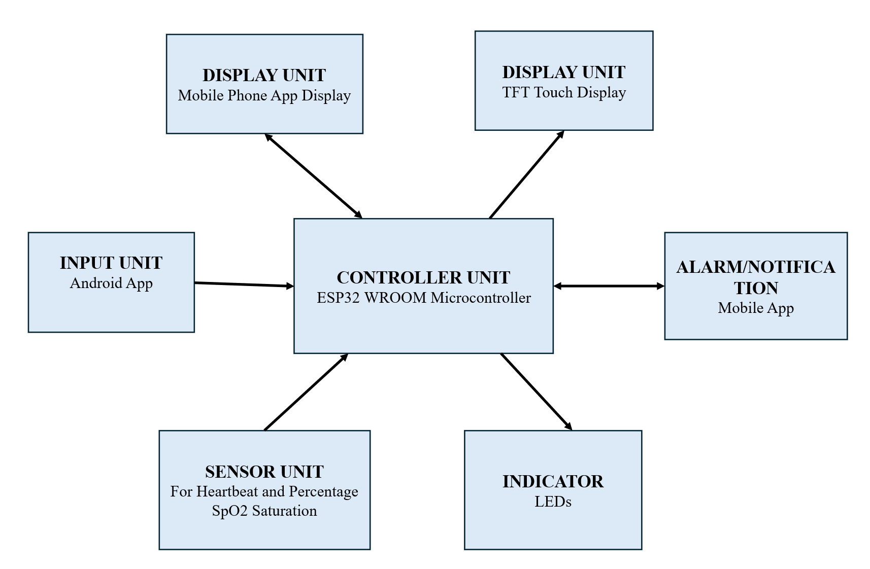
Figure 1: Block diagram of the Smart Medicine Box system architecture showing the interconnections between the ESP32 microcontroller, dual display units, and SpO2 sensor with the integration of the Android system.

2.1 Hardware Design
At the core of the system, an ESP32-WROOM microcontroller is employed as the central processing and control unit. The microcontroller coordinates sensor data acquisition, medication scheduling, display control, alarm activation, and communication with the Android-based mobile application. The ESP32-WROOM is selected due to its integrated wireless connectivity, low-power operation, and suitability for IoT-based healthcare applications. These features enable real-time interaction between the embedded hardware and the Smart Med Alert mobile application [10].

Figure 2 presents the system-level architecture of the Smart Medicine Box platform. The patient-end layer includes the Smart Medicine Box and mobile application, which are responsible for medication assistance, user interaction, and data exchange. The mobile application communicates with the Home Assistant Nurse module through an inter-app data link. This module manages patient data, physiological measurements, and feedback information before forwarding relevant updates to the doctor’s interface. The physician can review the information received and provide necessary feedback or recommendations. Thus, the architecture establishes an integrated communication framework among the patient, mobile application, caregiver/nurse module, and doctor to support remote medication monitoring and healthcare supervision.

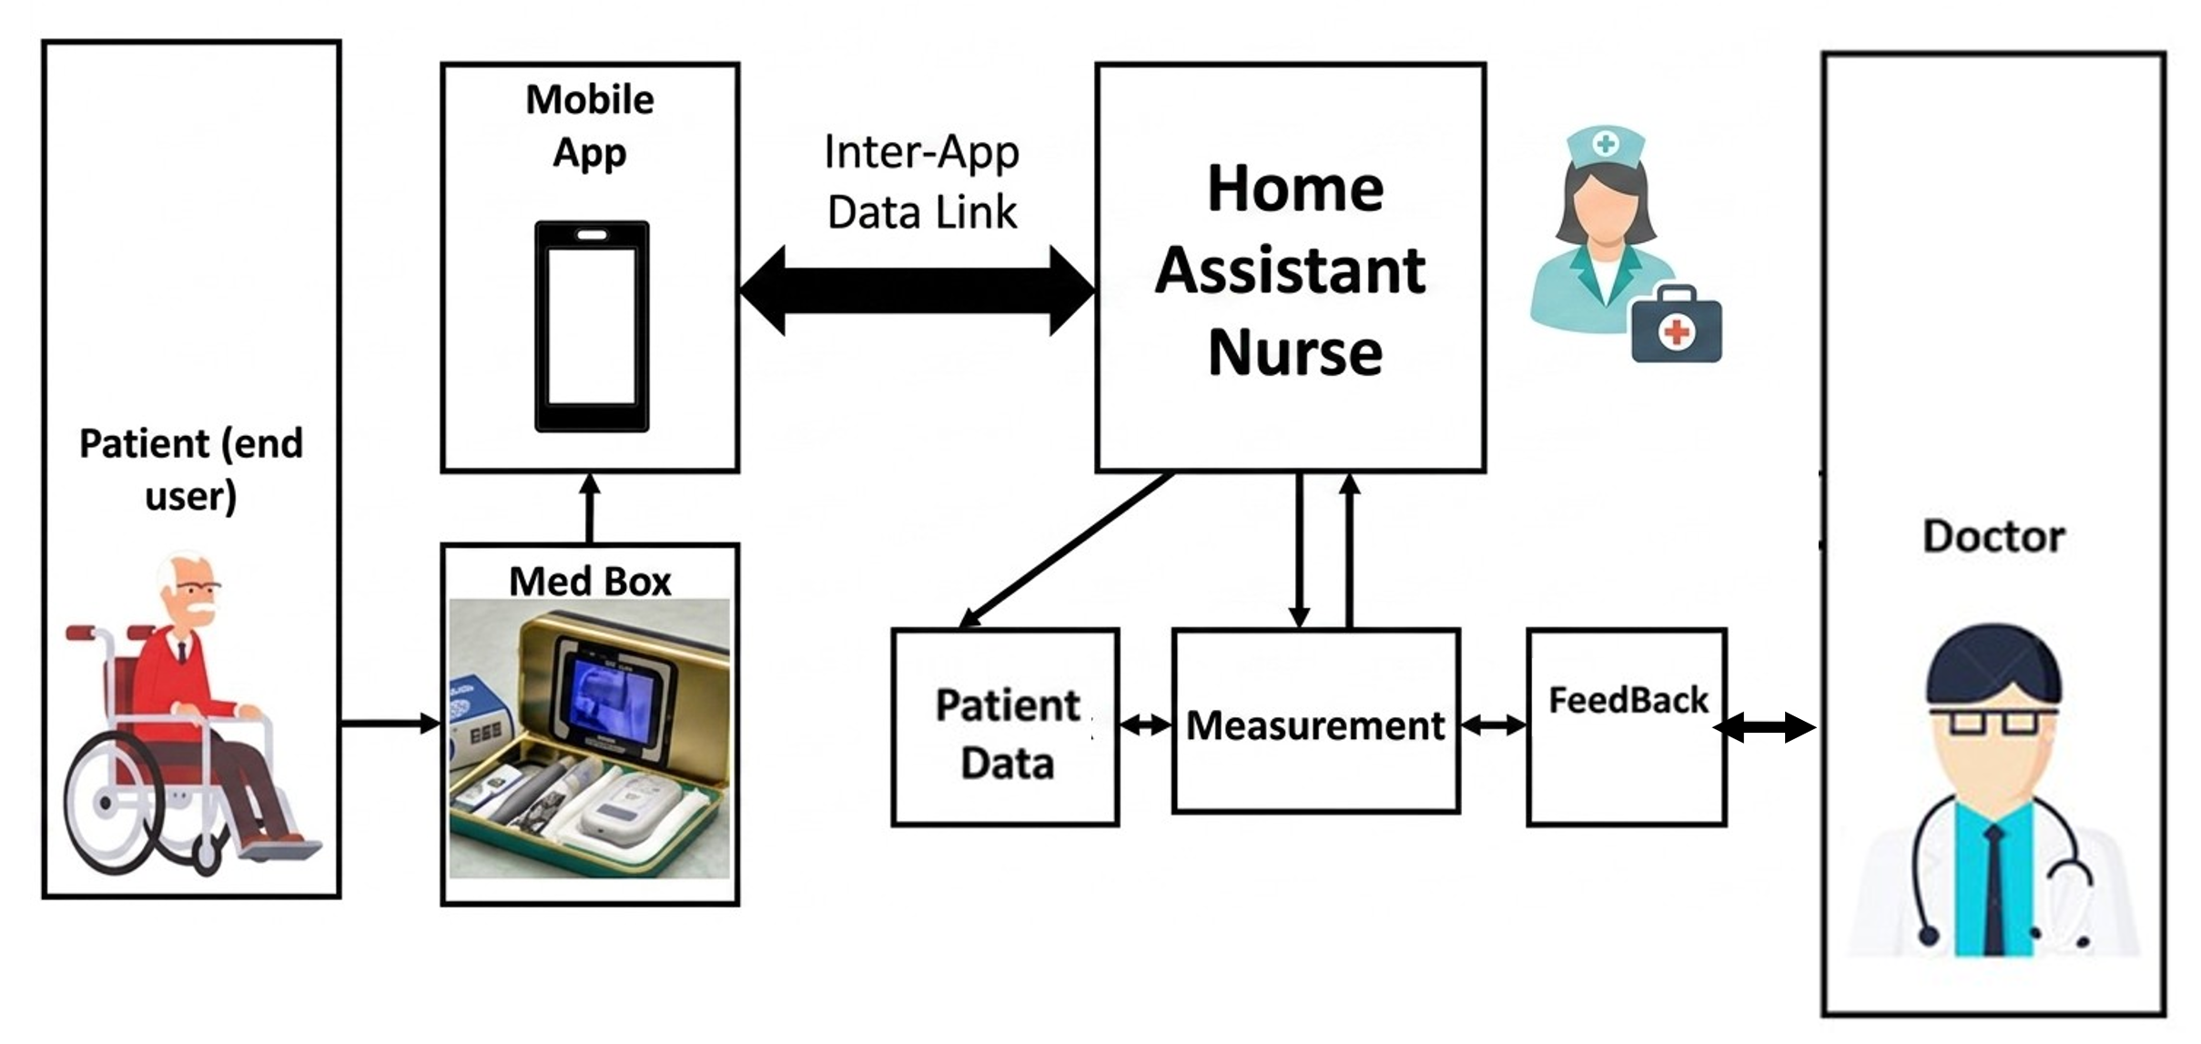
Figure 2: System architecture diagram showing the interconnections between the patient-end devices (Med Box and Mobile App), the Home Assistant Nurse management layer, and the physician interface.

The physical infrastructure of the Smart Medbox Alert System is built around a centralized edge-computing topology [11]. At the core of this architecture lies the Espressif ESP32-WROOM-32 microcontroller. The ESP32 was selected as the primary processing node due to its dual-core Tensilica Xtensa LX6 microprocessor architecture, which is critical for parallelizing the high-frequency biometric sampling required by the sensor suite without interrupting the asynchronous Wi-Fi (802.11 b/g/n) communication required for cloud synchronization [12]. The hardware logic operates at 3.3V logic levels. The ESP32 serves as the master controller, directly governing the digital state of the segmented pill compartments and communicating with the biometric sensor module via the Inter-Integrated Circuit (I2C) communication protocol.
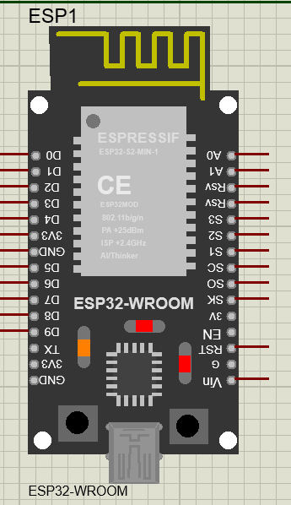
Figure 3: ESP32-WROOM Microcontroller Module Used as the Central Controller of the Smart Medicine Box System.

The physical medication storage is divided into three discrete temporal compartments: Morning, Lunch, and Night. Each compartment functions as an independent hardware subsystem equipped with its own local feedback loop, aimed at improving patient medication adherence [13]. State Indication (LED Matrix): Each compartment is equipped with a bi-color optical feedback system consisting of a Green LED (Standard 5mm, ~2.0V forward voltage) and a Red LED. To prevent current draw from exceeding the ESP32's maximum per-pin limit (40mA) and to ensure optimal brightness, each LED is placed in series with a 220Ω current-limiting resistor. The Green LED acts as an "Idle/Ready" indicator, while the Red LED serves as the active "Alarm" indicator. Interaction Detection: To monitor patient compliance, each compartment lid is equipped with a mechanical switch circuit. Rather than utilizing external pull-up or pull-down resistors, the hardware architecture leverages the ESP32's internal INPUT_PULLUP circuitry. The physical switches bridge the respective digital GPIO pins (D22, D23, D32) directly to a common ground. When a compartment lid is opened, the circuit completes, pulling the pin LOW. The edge firmware registers this state change as a confirmed pill consumption event.

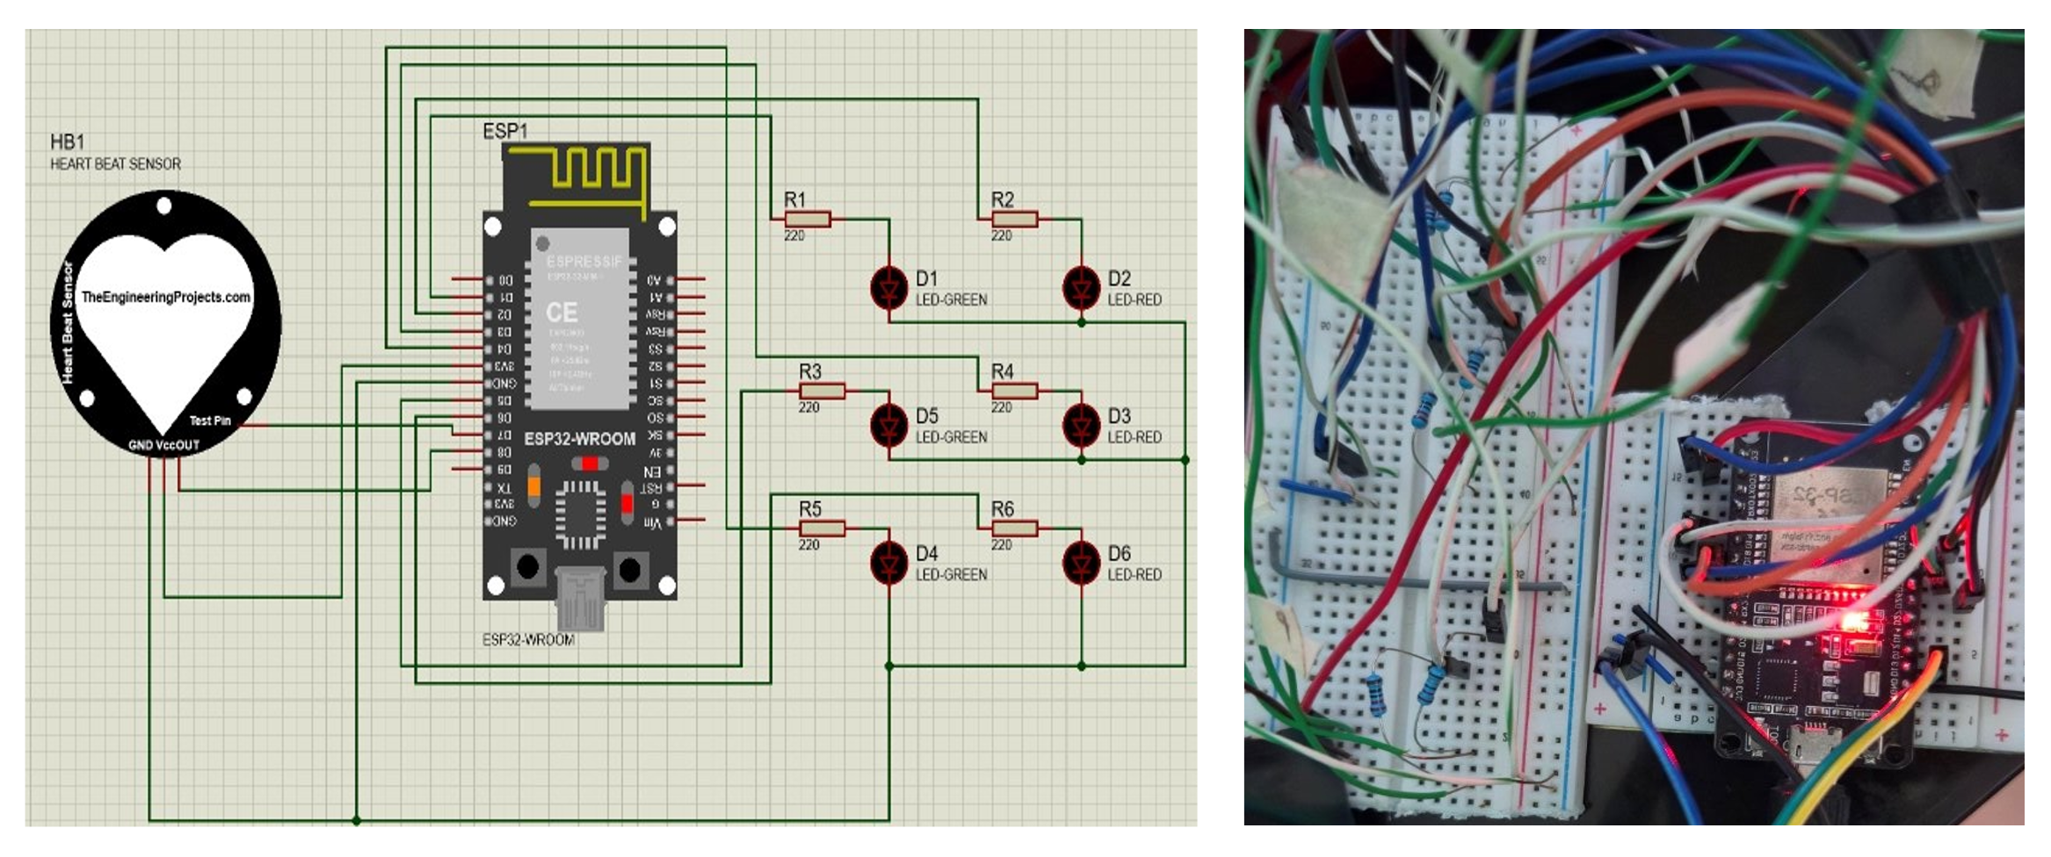
Figure 4: Schematic design and experimental hardware implementation of the ESP32-based smart medicine box circuit with heartbeat sensor and LED indicator units.

To facilitate the localized tracking of patient vitals, the architecture incorporates a MAX30102 high-sensitivity pulse oximeter and heart rate sensor [14]. This module operates on the principle of reflective photoplethysmography (PPG). Optical Array: The module contains two specialized light-emitting diodes: a Red LED (660nm) and an Infrared (IR) LED (880nm). These wavelengths are optimized to measure the differential absorption of light by oxygenated and deoxygenated hemoglobin in the peripheral capillary bed. Data Acquisition: A built-in high-resolution Analog-to-Digital Converter (ADC) captures the reflected optical data. To ensure rapid data transfer to the primary processor, the sensor is interfaced with the ESP32 via an I2C bus running at a Fast Mode clock speed (400 kHz). The I2C lines are remapped to GPIO pins D12 (SDA) and D13 (SCL) to optimize the physical routing of the circuit board.
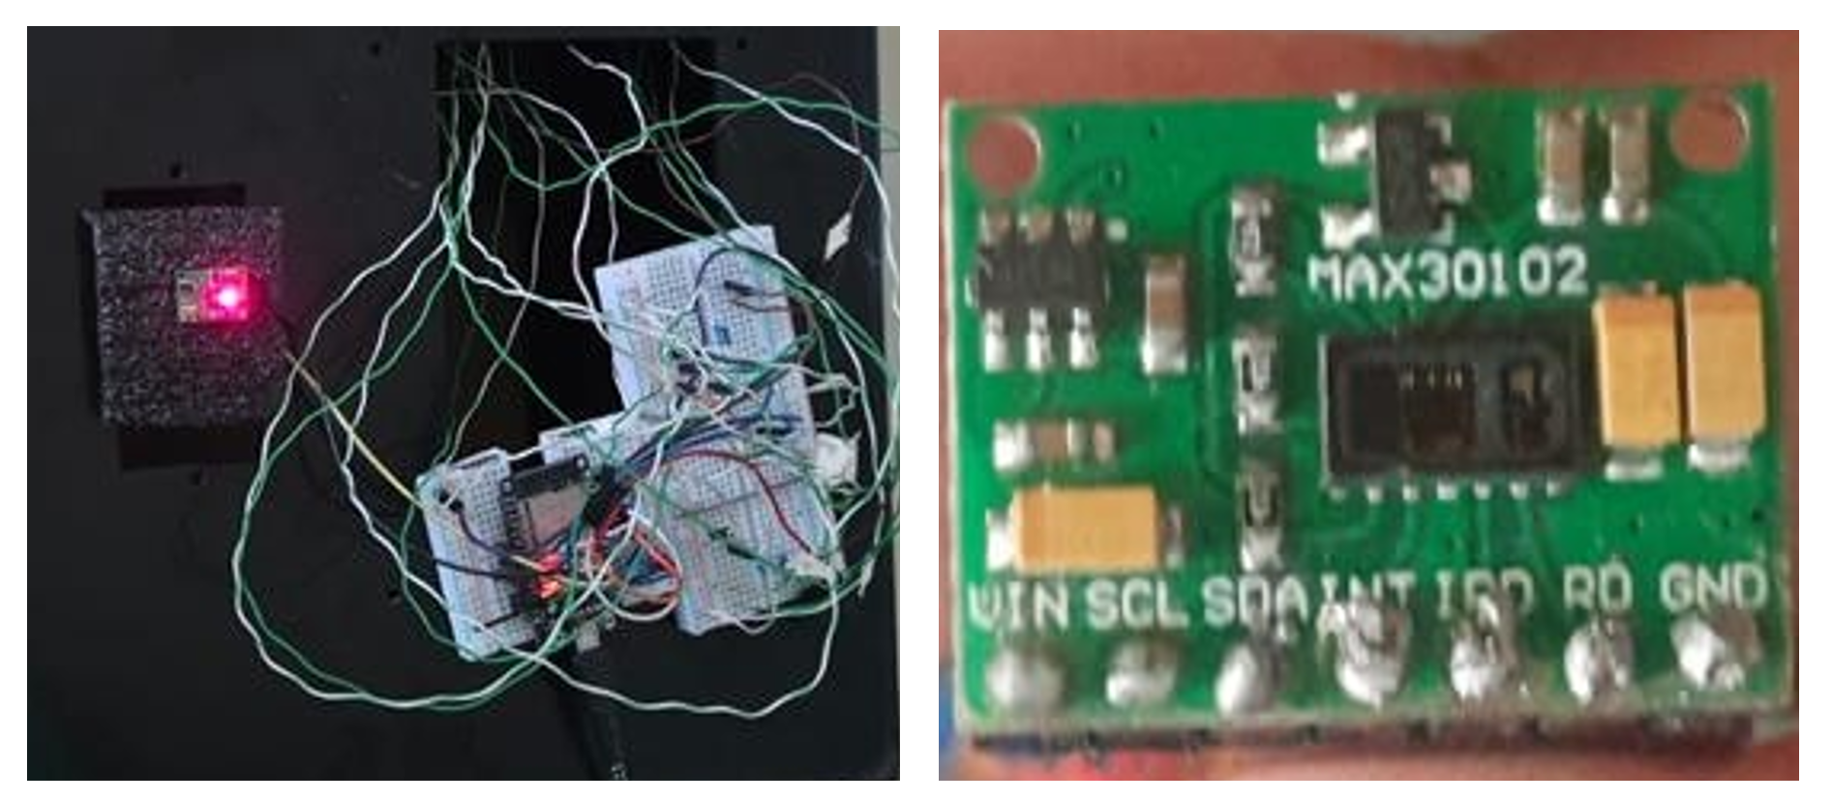
Figure 5: Experimental hardware setup of the smart medicine box system with the MAX30102 heartbeat and SpO₂ sensor module.
The entire hardware suite is designed to be powered via a standard 5V USB interface. The power topology utilizes the ESP32 development board's onboard Low-Dropout (LDO) linear voltage regulator to step the 5V input down to the stable 3.3V required by the Xtensa microprocessor and the MAX30102 sensor logic. By actively monitoring the IR data buffer, the hardware employs an algorithmic power-saving mechanism. The ESP32 dynamically flushes the measurement arrays when the IR reflection drops below a critical threshold (indicating the absence of a finger), effectively forcing the sensor into a low-power "Idle State" when not actively gathering biometric samples.
The complete hardware implementation of the Smart Medicine Box is illustrated in Figure 6. The prototype consists of a multi-compartment medicine storage unit integrated with an ESP32-WROOM microcontroller as the central control element. LED indicators are positioned adjacent to the compartments to provide visual medication reminders and status notifications. The embedded control circuitry is developed on breadboards and interconnected through jumper-wire connections for prototype validation. In addition, a MAX30102 sensor module is incorporated to monitor heart rate and blood oxygen saturation (SpO₂). The acquired physiological data are processed by the ESP32 and can be utilized for basic patient health monitoring. Figure 6 presents both the overall hardware assembly and the detailed controller implementation, highlighting the integration of medication management and physiological sensing functionalities within a single embedded healthcare platform. The developed prototype demonstrates the feasibility of combining adherence support with real-time health monitoring in a compact and cost-effective system.

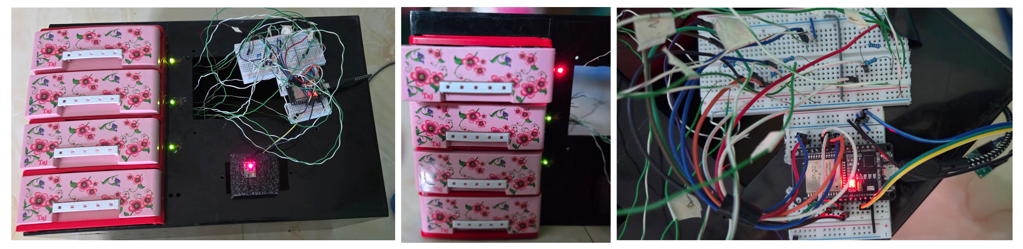
Figure 6: Hardware implementation of the Smart Medicine Box prototype showing the ESP32 microcontroller, 7-inch display, sensor modules, medicine compartments.
The spatial layout and interconnection of the key hardware components are illustrated in Figure 7. The MAX30102 sensor module acquires physiological parameters, including heart rate and blood oxygen saturation (SpO₂), and transmits the measured data to the ESP32-WROOM microcontroller for processing. The processed information is displayed locally through a 7-inch display and simultaneously synchronized with a cloud/server platform. The cloud infrastructure further facilitates data exchange with a mobile application, enabling remote monitoring and management. This architecture integrates physiological sensing, embedded processing, local visualization, cloud connectivity, and mobile-health access within a unified healthcare platform.
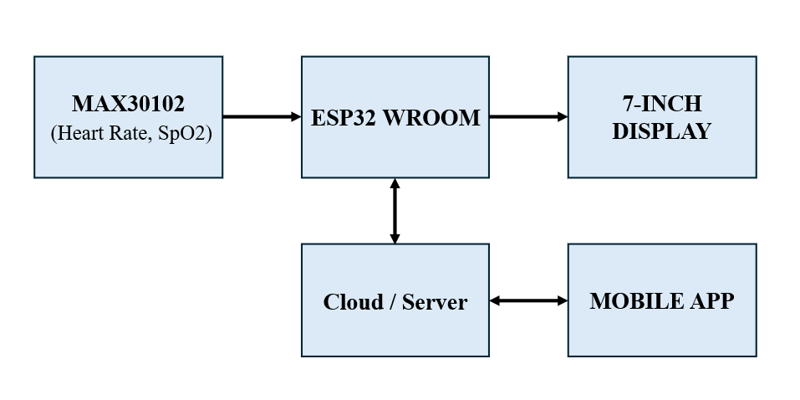
Figure7: 2D system architecture of the Smart Medicine Box showing the spatial layout and interaction among key hardware components including ESP32 microcontroller, biomedical sensors (MAX30102), 7-inch display, and mobile app.

2.2 Software Architecture of a Smart Medication Management and Vital Signs Monitoring System
2.2.1 System Overview
The suggested Smart Medbox Alert System utilizes a decentralized, three-tier Internet of Things (IoT) architecture, consisting of an Edge Node (ESP32 microcontroller), a Cloud Infrastructure (Google Firebase), and a Client Application (Android native application). This topology guarantees elevated fault tolerance, asynchronous communication, and real-time synchronization. The software design is divided into four main subsystems: Optical Character Recognition (OCR) for prescription analysis, high-frequency biometric sensor synchronization, autonomous scheduling, and inventory management.
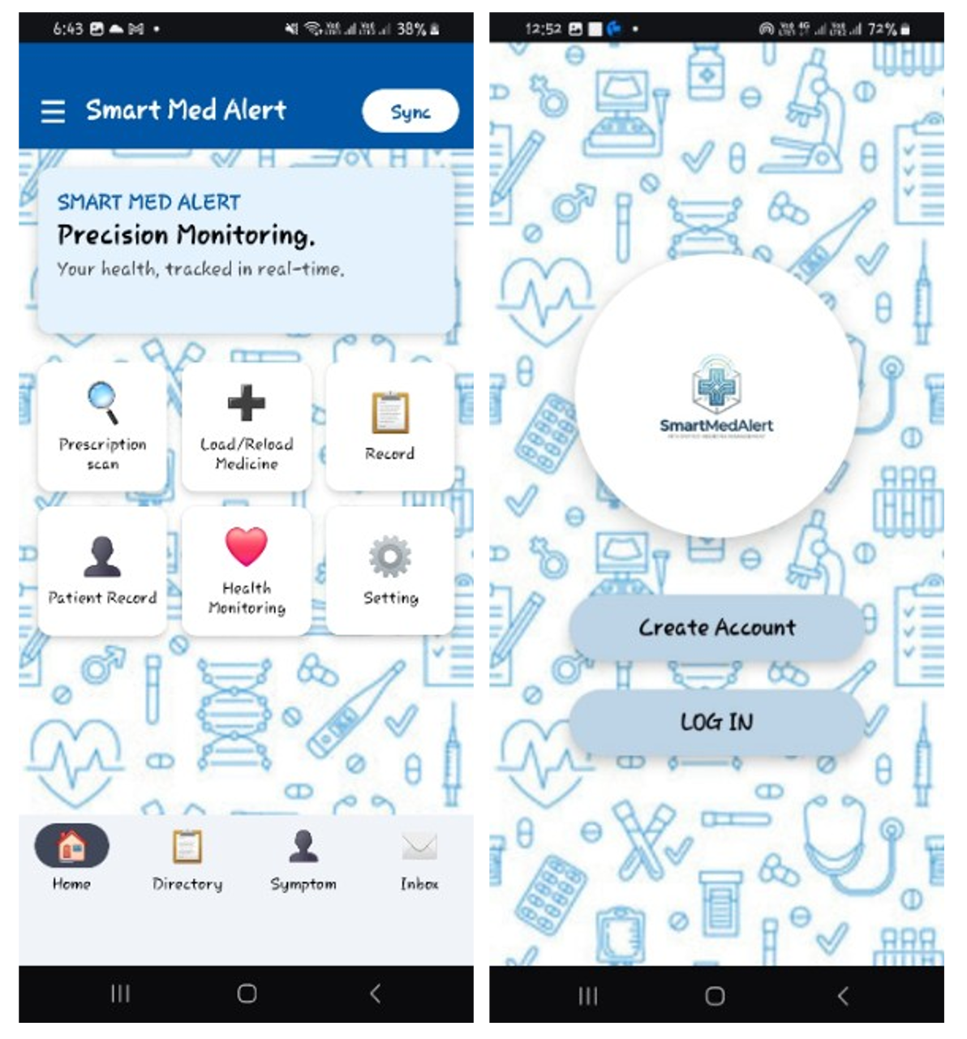
Figure 8: Smart med alert mobile application interface showing home dashboard and login screen.
2.2.2 Machine Learning (ML) Prescription Extraction Subsystem
The client application incorporates a machine-learning-driven prescription extraction workflow utilizing Google ML Kit to eradicate manual data entry errors. This subsystem's architecture functions in three consecutive stages:
- Image Processing and OCR: The program collects a prescription image using the device camera or gallery and transforms it into an InputImage object. The ML Kit Text Recognition API analyzes the image to retrieve unprocessed text segments and their corresponding bounding box coordinates.
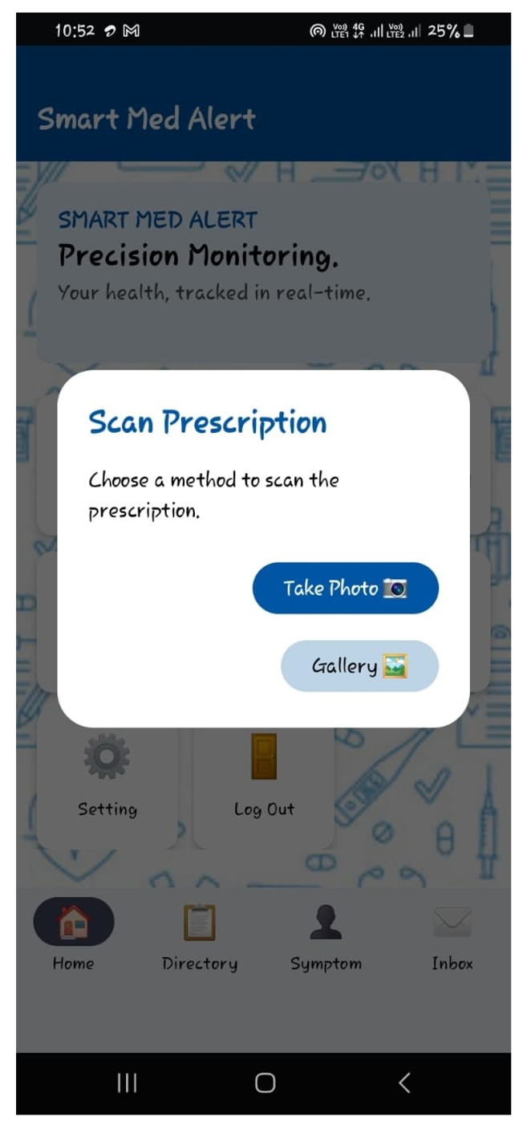
Figure 9: Prescription scanning interface of the smart med alert app showing camera and gallery selection options.

- Spatial Sensoring: A bespoke spatial sorting algorithm arranges unstructured text lines according to their vertical (Y-axis) and horizontal (X-axis) boundary coordinates, thereby reproducing the tabular format of conventional medical prescriptions.
- Fuzzy Parsing and dictionary matching: The program use Regular Expressions (Regex) to detect numerical dosages (e.g., "500mg"), length (e.g., "5 days"), and ingestion time indicators (e.g., "1+0+1"). To precisely ascertain the medication name despite handwriting discrepancies or OCR inaccuracies, the system calculates the Levenshtein distance between the extracted string and a local JSON-based medical lexicon. If the distance is within an acceptable range, the medication name is standardized and securely transmitted to Cloud Firestore.
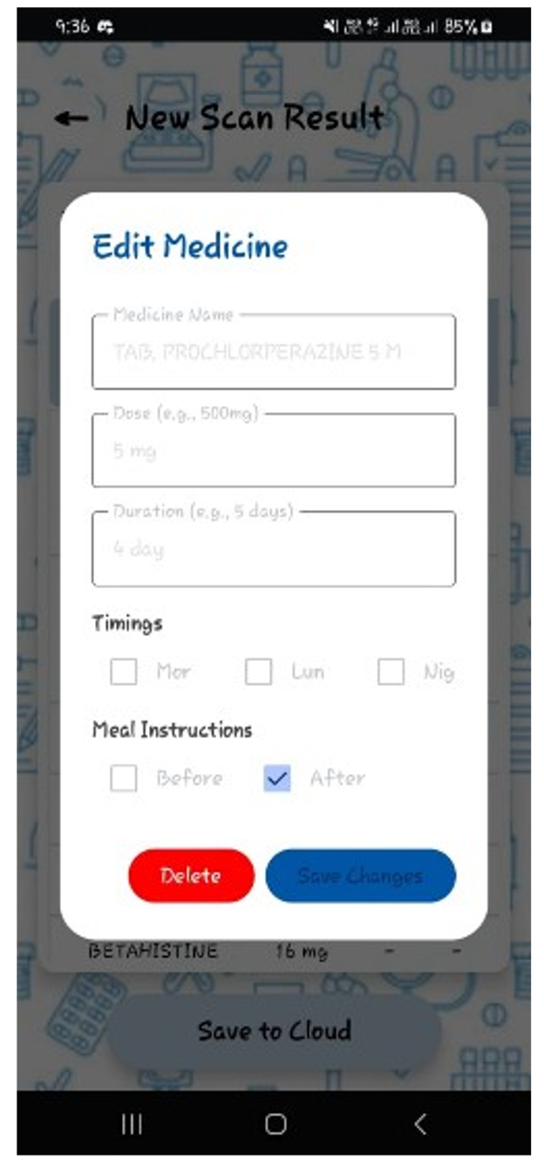
Figure 10: Smart med alert medicine editing interface showing dosage, duration, timing, and meal instruction options.
2.2.3 Real-Time Synchronization of Hardware and Sensors
The system utilizes a MAX30102 photoplethysmography (PPG) sensor to measure Heart Rate (HR) and Blood Oxygen Saturation (SpO2). Processing this raw optical data demands precise timing, requiring a dual-core software design on the ESP32 utilizing FreeRTOS.
- Core 1 (Biometric Processing): A specialized FreeRTOS activity executes the PPG algorithm at a sample frequency of 400Hz. It employs a continuous sliding window mechanism and a software-based moving average filter (size=5) to mitigate high-frequency motion artifacts. An adaptive infrared (IR) threshold (IR < 15,000) effectively governs an "Idle State," purging extraneous data immediately upon finger removal.
- Core 0 (Cloud Sync): The second core manages Wi-Fi connectivity, retrieves Network Time Protocol (NTP), and ensures SSL encryption for Firebase.
Upon the detection of valid HR and SpO2 data on Core 1, Core 0 promptly transmits an HTTPS PATCH request to the Firestore database. In contrast, the Android application employs Firestore's addSnapshotListener, creating a persistent WebSocket connection that refreshes the mobile User Interface (UI) in real-time without the need for manual polling.
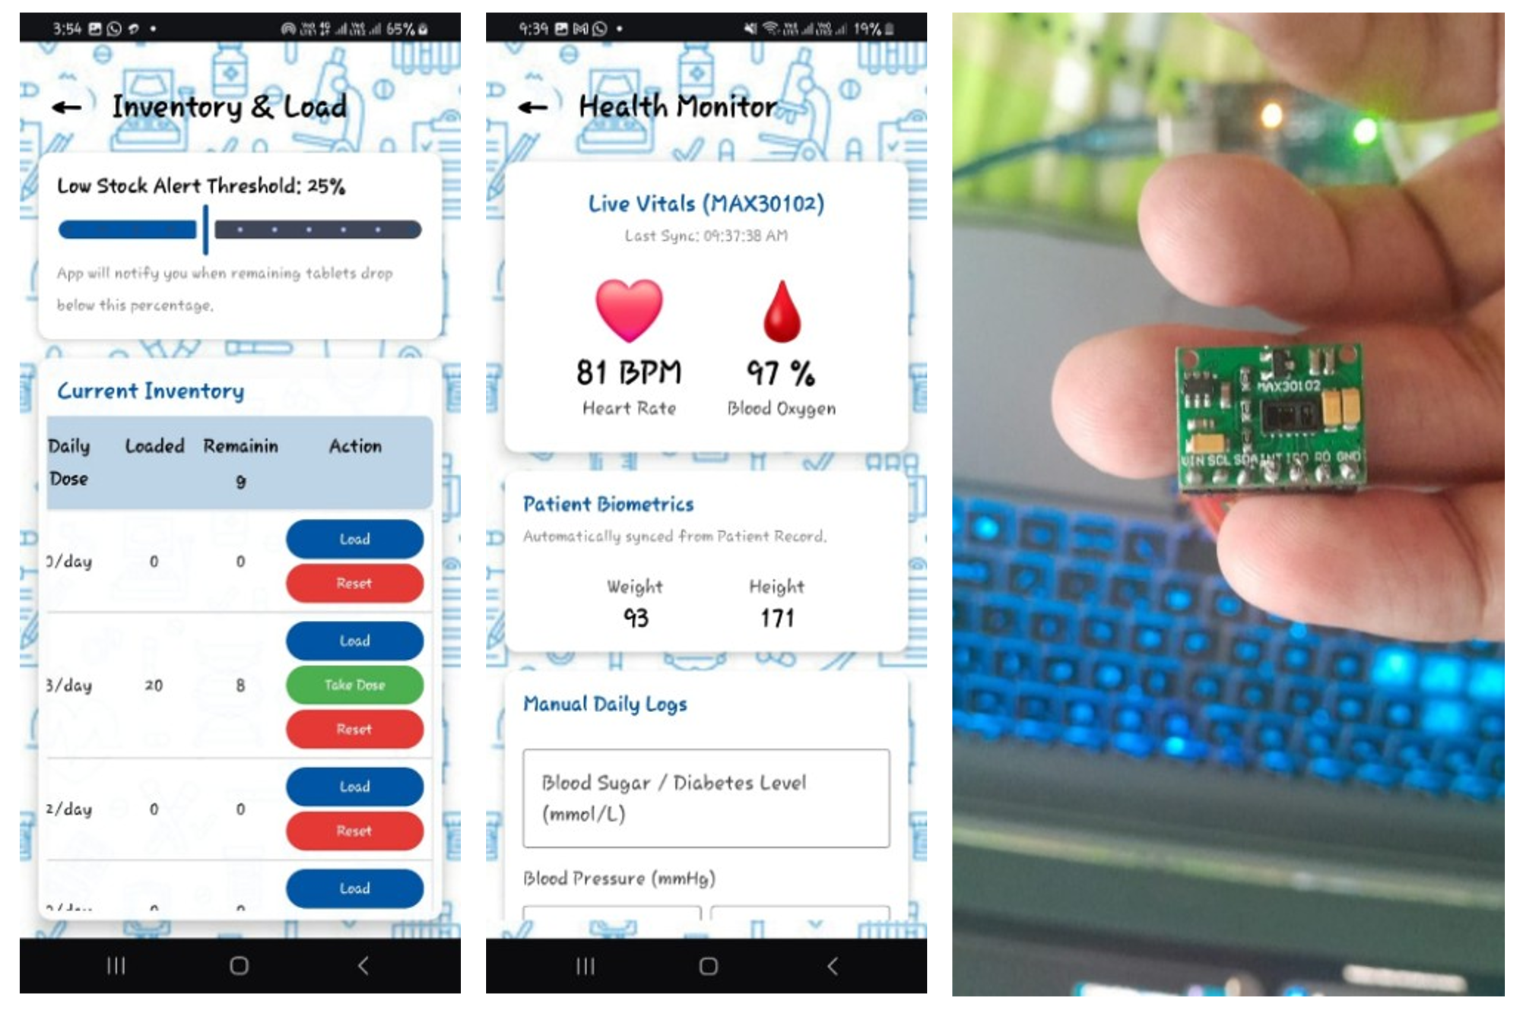
Figure 11: Smart med alert inventory management and health monitoring interface integrated with MAX30102 biometric sensor.
2.2.4 Autonomous Scheduling and Alarm System
A prevalent failure point in mobile-dependent IoT systems is the latency induced by smartphone energy conservation strategies (e.g., Android Doze Mode). The architecture separates the physical hardware alarms from the mobile operating system to address this issue. Upon defining a prescription schedule, the Android application securely stores the TargetTime in the cloud. Upon initialization, the ESP32 retrieves the universal atomic time from an NTP server (synchronized to UTC+6). The microcontroller continuously compares its internal hardware clock with the cloud-specified TargetTime. When the times coincide, the ESP32 autonomously activates the physical LED and buzzer alarms. The Android application employs AlarmManager with setExactAndAllowWhileIdle to deliver a local OS-level notice to the user's device. To guarantee patient safety, the edge firmware has a "Overdose Protection" protocol; if a user neglects a dose and a subsequent alarm activates, the ESP32 autonomously clears the previous missed alarm from both the physical pins and the cloud database, guaranteeing that only the most recent dose remains active.
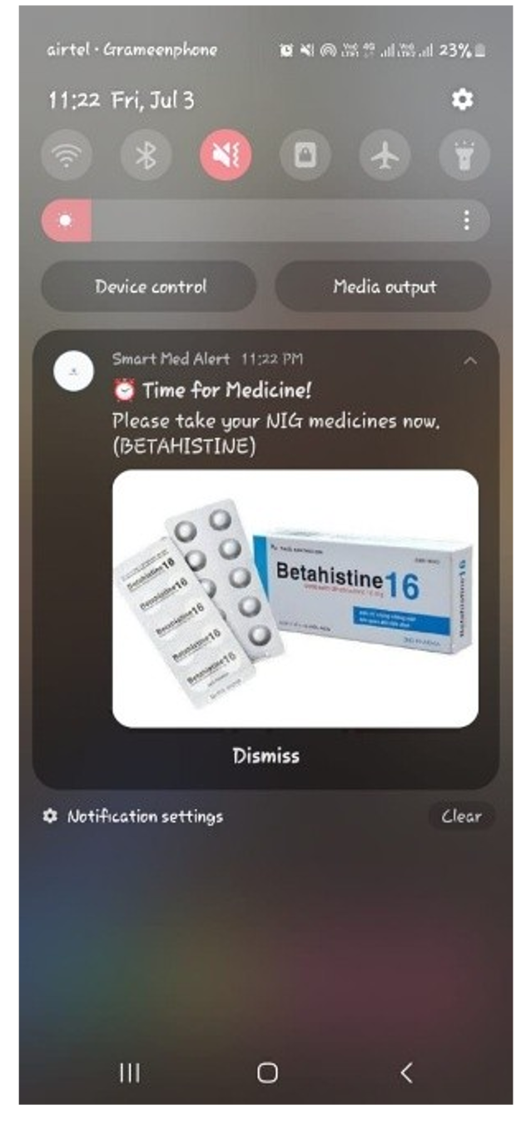
Figure 12: Smart med alert medication reminder notification showing scheduled intake alert for Betahistine.

2.2.5 Inventory Oversight and Low-Stock Notification
The solution upholds a cloud-based ledger of pharmaceutical inventory, juxtaposing tabletsLoaded with remainingTablets. The deduction architecture is activated by hardware: when the patient physically engages with the medbox to ingest a pill, a magnetic reed switch transmits a LOW signal to the ESP32. The ESP32 records the exact NTP timestamp and reduces the currentTakenCount in Firebase. The Android client monitors these hardware state alterations. Upon detecting a switch trigger, the application cross-references the consumed slot (Morning, Lunch, or Night) with the user's prescription matrix, algorithmically determining the specific pill count. The application perpetually computes the residual proportion of the total inventory loaded. When the remaining tablets fall below a user-specified level (e.g., 25%), the application activates an immediate Low Stock Alert through the Android NotificationManager, urging the user to replenish the physical box.
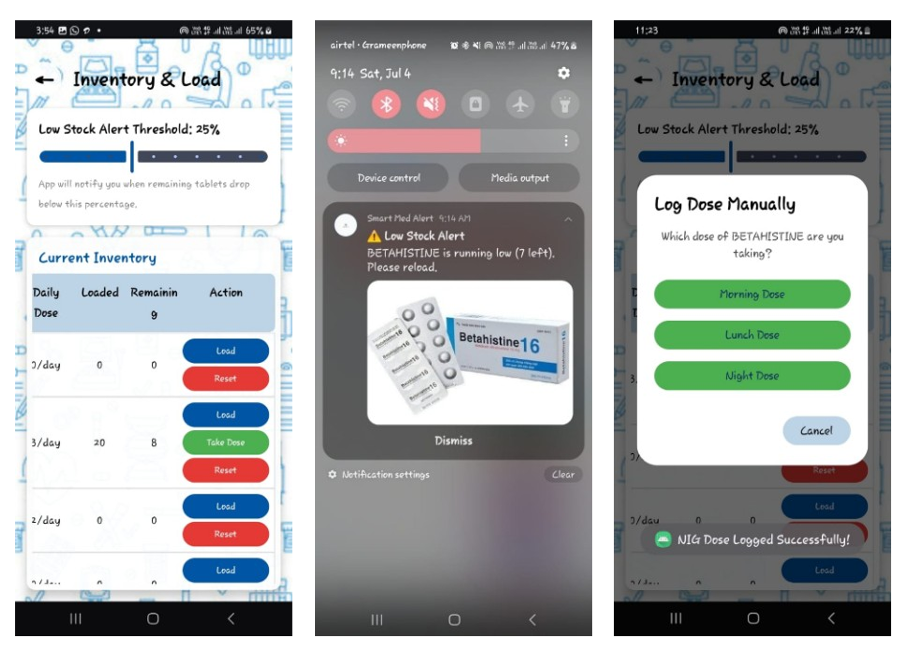
Figure 13: Smart med alert inventory management interface showing low-stock notification and manual dose logging options.
2.2.6 Monitoring of Medication Compliance (Record Section)
The architecture features a dynamic History module that persistently records precise drug consumption events to monitor patient compliance. This solution, unlike conventional programs that depend solely on manual user input, captures the exact Network Time Protocol (NTP) timestamp at the instant the physical ESP32 pillbox is opened. The Android client acquires this data using real-time Firestore listeners, classifying daily doses into specific visual states: 'Taken', 'Pending', or 'Missed'. This detailed, hardware-based tracking system significantly minimizes self-reporting bias, offering a precise and unalterable record of the patient's daily medication adherence at morning, lunch, and evening intervals.
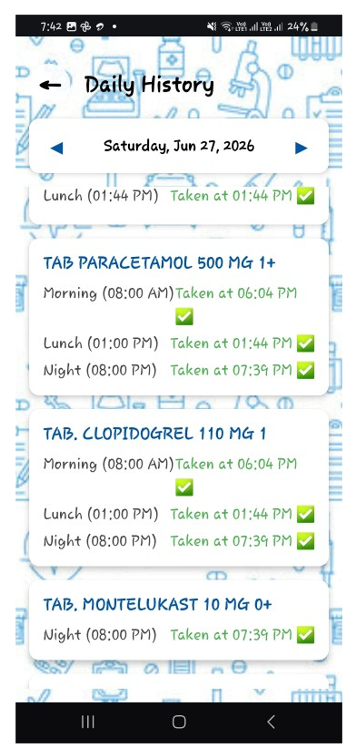
Figure 14: Smart med alert daily medication history interface showing scheduled dose records and intake confirmation status.

2.2.7 Data Consolidation and Report Exportation
The application has a comprehensive data export subsystem to connect automated IoT tracking with clinical evaluation. Users may choose specific date ranges (e.g., 7 days, 30 days, or bespoke intervals) to produce detailed, offline-accessible CSV (Comma-Separated Values) reports. The backend export algorithm methodically consolidates data from three separate Firestore collections: static patient biometrics, active prescription matrix, and timestamped adherence records. By integrating this complex data into a unified, standardized spreadsheet, the system provides healthcare professionals with practical, objective insights on the patient's long-term adherence patterns, enabling data-driven medical interventions.
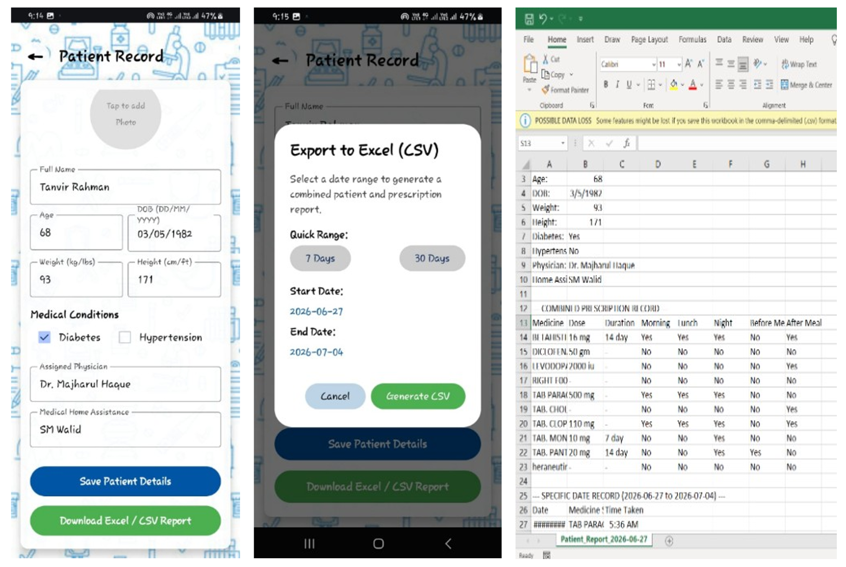
Figure 15: Smart med alert patient record management interface showing patient data entry, csv export option, and generated excel report.

3. Functional Implementation
The medication reminder system functions on a schedule set by the user or caregiver [6]. At the scheduled time, it activates the appropriate drawer indicator, triggers LED alerts, and updates the mobile app interface. When the correct compartment is opened, the system logs this as a successful dose administration [15]. The operational flow of the Smart Medicine Box is illustrated in the flowchart shown in Figure 16. The ESP32-WROOM functions as the central controller and supports three independent interaction pathways: (i) a touch-screen interface through a 7-inch display, (ii) a non-invasive sensing module, and (iii) a mobile application interface. Data acquired from these sources are processed by the ESP32-WROOM and exchanged through a Firebase Cloud Server to ensure data synchronization and remote accessibility. The cloud platform facilitates communication between the embedded hardware and the mobile application, while sensor readings and system status are presented through the display and LED indication modules. This architecture enables integrated sensing, user interaction, cloud connectivity, and real-time monitoring within a unified healthcare platform.

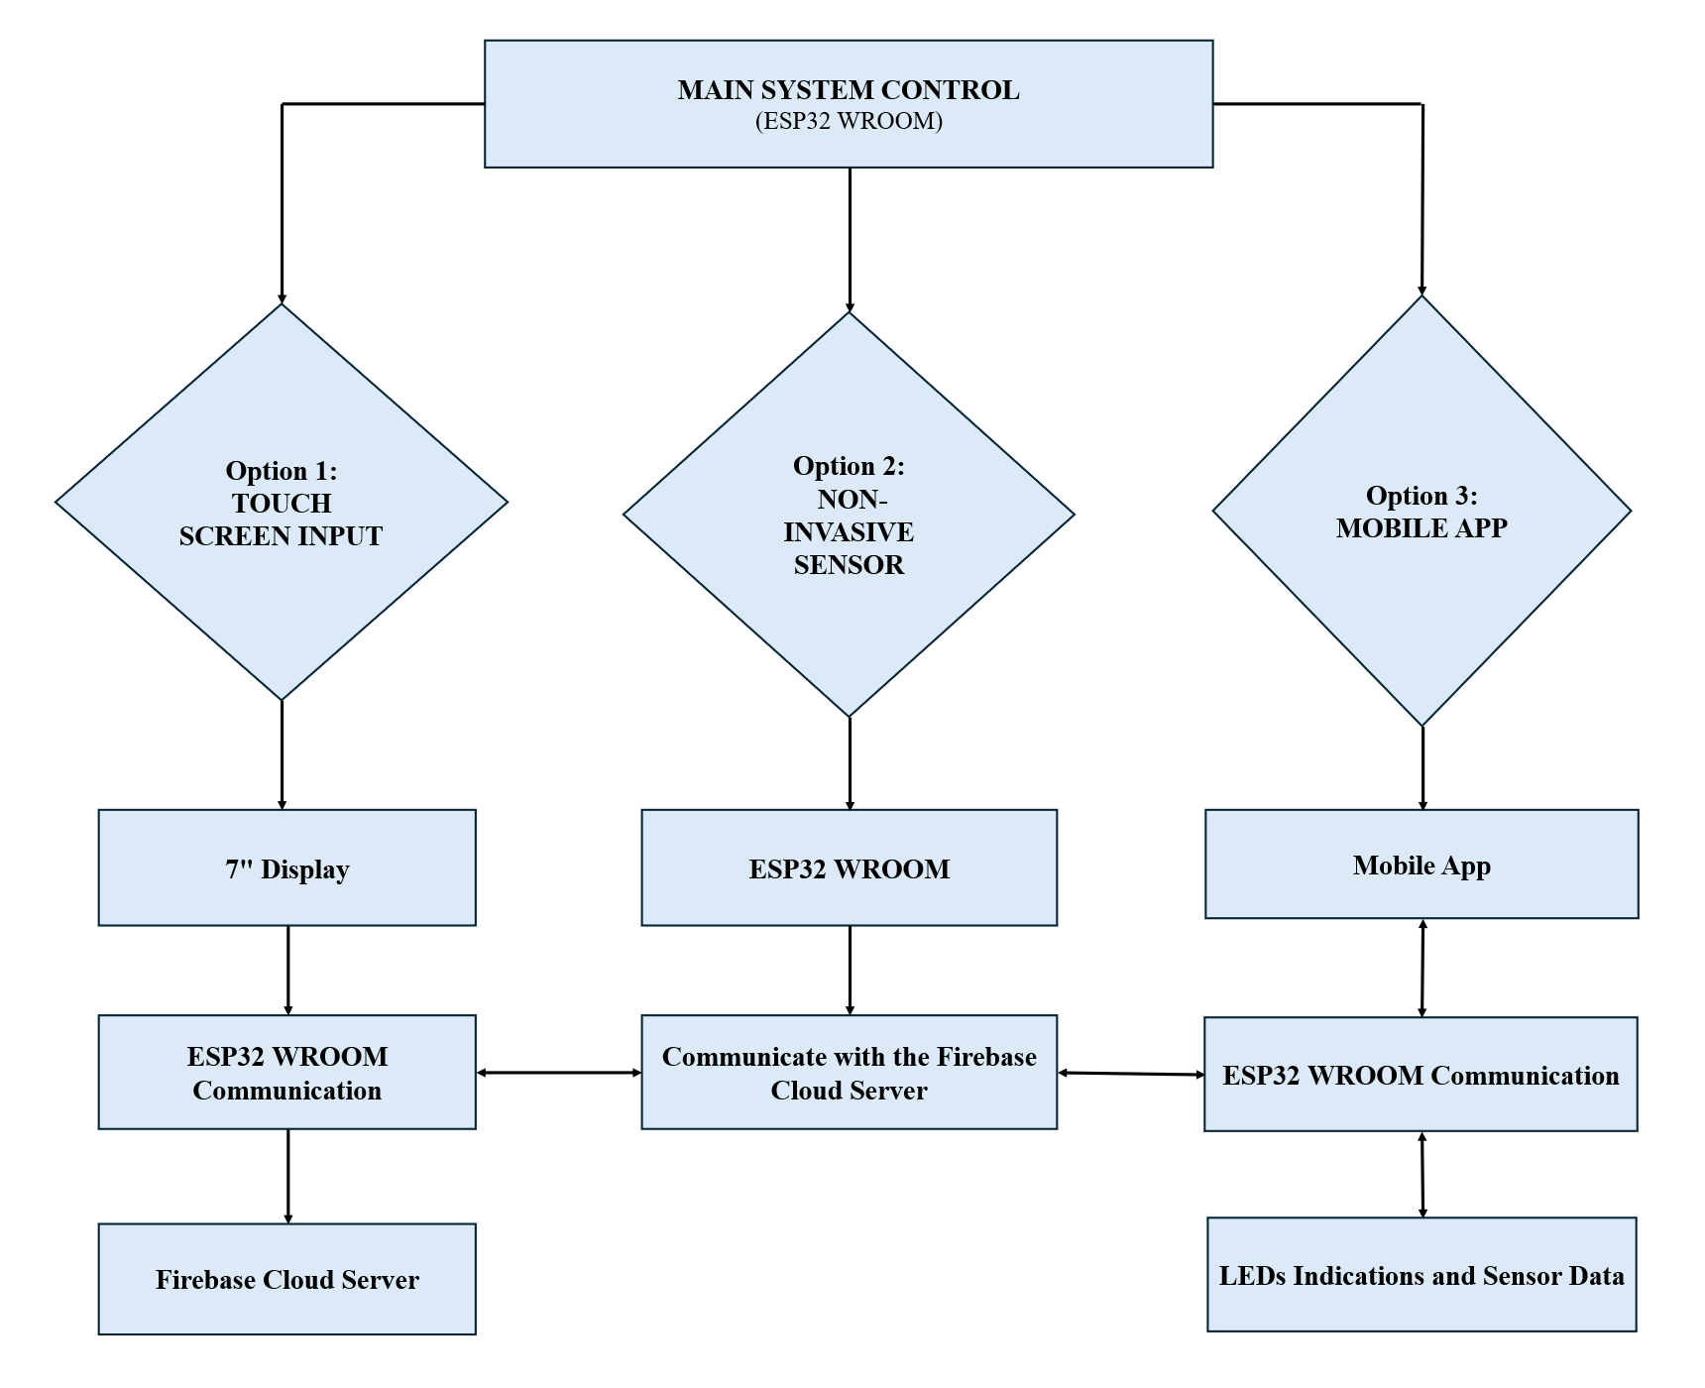
Figure16: Operational flowchart of the Smart Medicine Box illustrating the ESP32-WROOM Main Controller with Triple-Input Modalities (Touch Screen, Non-Invasive Sensor, Mobile App) and Firebase Cloud Integration.
The medicine reminder mechanism is illustrated in Figure 17, demonstrating the multimodal alert system in action. The mobile application provides medication scheduling, dose configuration, image-based medicine identification, and daily adherence history. The daily history interface displays scheduled medicines with their corresponding intake status, including pending and missed doses, while the medicine editing interface allows configuration of medicine name, dosage, duration, and alarm timing. The hardware prototype demonstrates the integration of the medicine storage unit, touch display, and LED-based visual indicators for real-time reminder presentation. Together, the mobile application and embedded prototype support medication scheduling, adherence tracking, and user-oriented reminder notification within the proposed system.

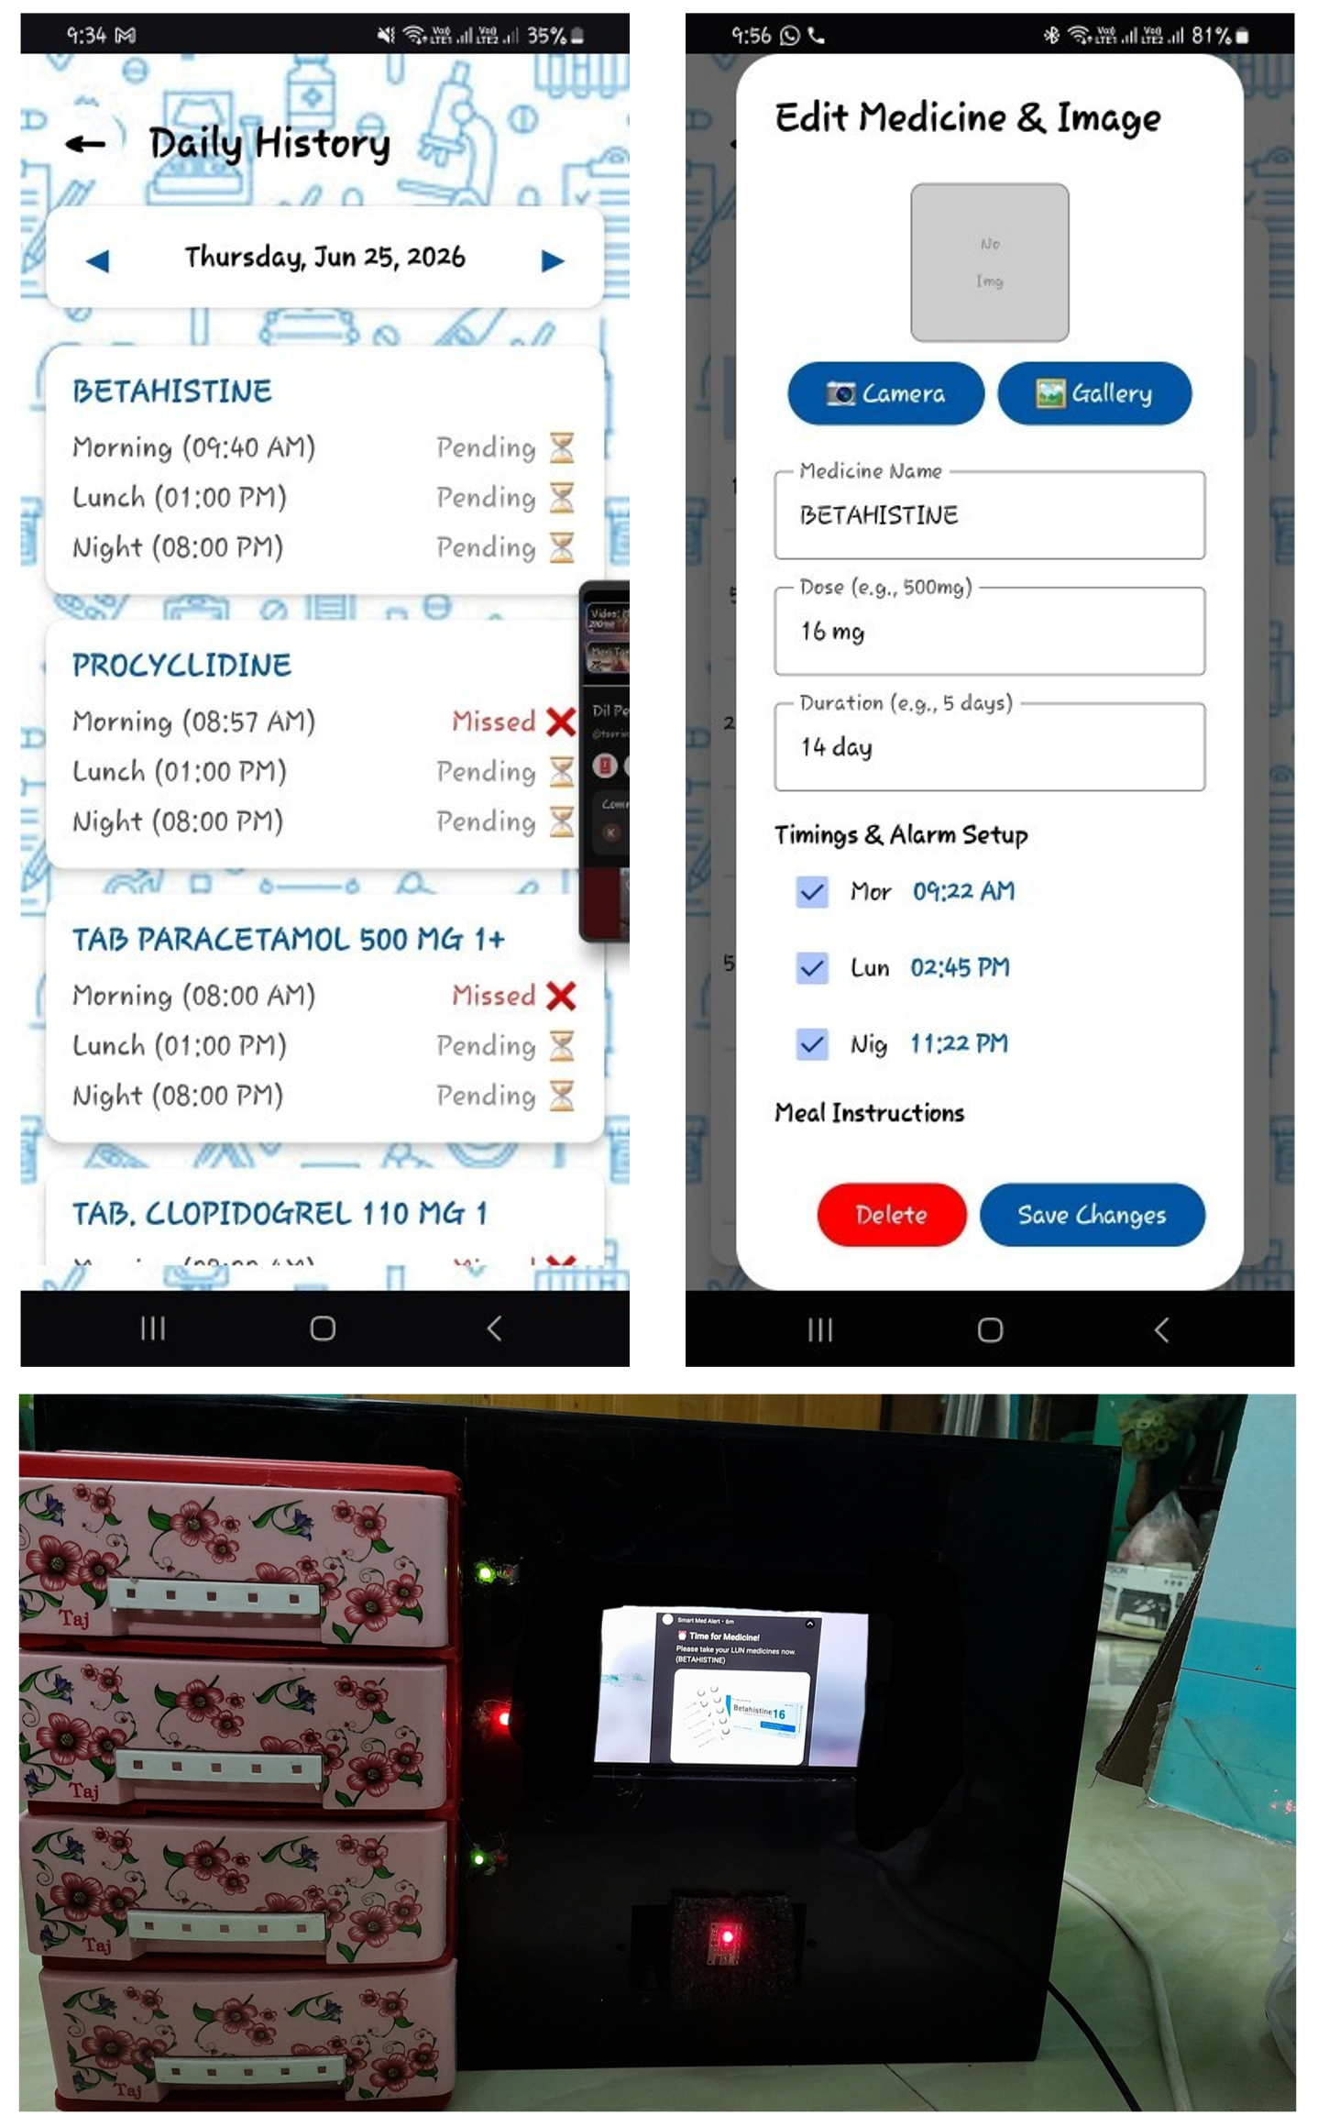
Figure 17: Medicine reminder mechanism showing the buzzer, LED indicators, and touch display alert during scheduled medication time.

The mobile application incorporates a medication intake reporting feature to support adherence monitoring and refill planning. The system generates an Excel-based report for a selected monitoring period, such as one week or one month, containing scheduled medication events, recorded intake status, and missed doses. By analyzing this report, users or caregivers can identify the total number of missed doses and determine the specific times at which medication intake was not recorded. This provides a structured and quantitative method for evaluating medication adherence beyond simple reminder generation. The generated report also assists in refill management by allowing caregivers to estimate medication consumption based on the prescribed schedule and recorded intake history. By reviewing the weekly or monthly intake report, caregivers can determine whether the medicine box requires refilling and plan timely replenishment of medication stock. Such report-based monitoring supports improved medication management, reduces the risk of missed doses, and contributes to safer long-term medication use.

Medicine Box and the Med Alert App can operate isolated in offline mode. For example, the indicators for taking medicine on time can be notified by the medicine box itself through the display of a device that does not need to take command from the app. Similarly, the app can send alerts to take medicine on a time-to-time basis with the picture of the medicine without being connected to Wi-Fi. However, to update the inventory list and keep a record of the medication intake up to date, it is required to communicate the app with the device. Hence, in such a case, an online condition is required to update and sync through the Firebase cloud to update the inventory system and records of intake.

4. System Positioning and Cost Comparison

A key design objective of the proposed Smart Medicine Box is to provide a cost-effective and user-friendly medication management solution without compromising essential functionality. To achieve this objective, the system is built around the ESP32-WROOM microcontroller and employs a modular architecture that integrates medication scheduling, reminder generation, physiological monitoring, cloud connectivity, and mobile application support. The system combines a MAX30102 sensor, a touch-display interface, LED-based status indicators, and Firebase cloud services to facilitate real-time monitoring and medication adherence tracking. Furthermore, the mobile application enables medication scheduling, adherence reporting, and remote access to patient records. The modular design simplifies system integration, reduces implementation complexity, and provides flexibility for future enhancements and expansion.

Table 1 presents the detailed bill of materials for both configurations.
Component | Base Model | Premium Model
Microcontroller | 5.56 | 10.00
Drawer detection (reed switches ×4) | 2.00 | 2.00
LEDs, resistors | 1.00 | 1.00
Max30102 | 5.00 | 5.00
Battery | 12.00 | 12.00
Enclouser | 5.00 | 5.00
Power supply (5V USB) | 2.00 | 2.00
Total Bill of Materials | 32.56 | 37.00
Estimated Retail Price | 65.00 | 70-80

To contextualize the economic positioning of this work, Table 2 compares the proposed system against representative existing solutions across technical and cost dimensions.

Table 2: Comparison with Existing Medication Management Systems
Feature | Basic Pill Organizer [7] | e-pill Reminder [7] | Hero Health [8] | Hospital Smart Cabinet [8] | Proposed (Base) | Proposed (Premium)
Reminder Type | Audible only | Audible + Visual | Audible + Visual + App | Audible + Visual + App | Audible + Visual + App | Audible + Visual + App
Adherence Verification | None | None | Drawer detection | Drawer detection + RFID | Drawer detection | Drawer detection
Caregiver Alerts | None | None | App only | App + SMS | App only | App + SMS + Escalation
Prescription Scanning | No | No | No | Yes | Yes | Yes
Expiry Tracking | No | No | No | Yes | Yes | Yes
Low Stock Alert | No | No | Yes | Yes | Yes | Yes
Health Monitoring Integration | No | No | No | No | Yes (Wi-Fi) | Yes (Wi-Fi, Bluetooth)
Offline Operation | Yes | Yes | No | Yes | Yes | Yes
Lockout Mechanism | No | No | No | Yes | No | Yes
Target Setting | Home | Home | Home | Clinical | Home | Home

As illustrated in Table 2, basic pill organizers provide only auditory reminders without any verification or connectivity [7]. Mid-range solutions such as the e-pill series add visual indicators but lack caregiver integration. The Hero Health system offers drawer detection and app-based alerts but requires continuous internet connectivity and lacks prescription scanning or expiry tracking [8]. Hospital-grade smart cabinets provide comprehensive features but are cost-prohibitive for household use, with prices ranging from 18,000 to 40,000 USD [8].
The proposed system occupies a unique position in this landscape. The base model offers essential adherence monitoring and caregiver alerts at a price point comparable to consumer devices, while the premium model adds advanced features such as IR-based verification, SMS escalation, and Bluetooth health monitoring that are typically found only in clinical-grade systems. This cost-optimized modular architecture enables users to scale functionality based on individual needs and budget constraints flexibility not commonly available in existing solutions [9].

5. Evaluation
5.1 Assessment of MAX30102 Biometric Sensor Precision
5.1.1 Enhancements in Accuracy and Architectural Effectiveness
The dependability of optical photoplethysmography (PPG) sensors, such as the MAX30102, is significantly affected by digital timing jitters and environmental noise. In the early iterations of IoT health devices, the sequential processing of sensor data and Wi-Fi transmission frequently results in lost samples and inconsistent vital values. The proposed design enhanced the clinical accuracy of the MAX30102 by isolating the processing logic within a FreeRTOS multitasking environment [16]. By allocating the biometric sampling duty exclusively to Core 1 of the ESP32’s Xtensa processor, the system attains a remarkably constant 400Hz polling rate across a Fast Mode Inter-Integrated Circuit (I2C) bus, unaffected by background network interruptions. Additionally, a stringent digital thresholding mechanism was implemented (IR < 15000). This guarantees that the measurement arrays are promptly cleared upon finger removal, hence reducing the computation of extraneous data and averting false positives. A real-time moving average filter with a temporal window of N = 5 was employed to smooth the resultant waveforms and reduce high-frequency motion artifacts in the heart rate and blood oxygen arrays.

5.1.2 Mathematical Basis for SpO2 Calculation
The MAX30102 measures blood oxygen saturation (SpO2) by emitting two distinct wavelengths of light: Red $660 nm) and Infrared (880nm). Oxygenated hemoglobin (HbO2) exhibits greater absorption of infrared light, whereas deoxygenated hemoglobin (Hb) demonstrates increased absorption of red light. The sensor's integrated Analog-to-Digital Converter (ADC) records these reflections, consisting of a direct current (DC) component (indicative of static tissue and venous blood) and an alternating current (AC) component (indicative of pulsatile arterial blood) [17].
The fundamental algorithm isolates the pulsatile signal to compute the "Ratio of Ratios" (R), mathematically defined as:

R = $\frac{(\frac{{AC}_{red}}{{DC}_{red}})}{(\frac{{AC}_{ir}}{{DC}_{ir}})}$
Upon dynamic computation of R from the localized peak and trough data within the sampling buffer, the empirical blood oxygen percentage is obtained utilizing the manufacturer's standard linear calibration formula [17]:

SpO₂ = 104 - 17R

The moving average filter utilized to stabilize the final heart rate (HR) and SpO2 outputs is determined by the discrete convolution equation:
$$\overline{x_{k}}= \frac{1}{N} \sum_{i=0}^{N-1}{x_{k-i}}$$
Here, $\overline{x_{k}}$ denotes the smoothed output, x signifies the raw computed metric, and N indicates the size of the smoothing buffer.
5.1.3 Prospective Areas for Optimization
The existing moving average filter offers fundamental stability, although the system's robustness against intense motion artifacts might be enhanced. Subsequent software versions ought to evolve from a rudimentary averaging method to an Infinite Impulse Response (IIR) or Butterworth low-pass filter to effectively diminish frequency noise beyond the human physiological range 0.5 Hz to 4.0 Hz [18]. The MAX30102, from a hardware standpoint, utilizes reflecting optics, rendering it susceptible to ambient light saturation, such as intense sunlight or fluorescent flashing. Incorporating a 3D-printed optical shield or an acrylic baffle over the sensor module would limit the entry of ambient light. Moreover, varying finger pressure modifies capillary density, distorting the AC signal. The implementation of a mechanical spring-loaded clip mechanism would normalize the pressure exerted on the diode array, hence enhancing the repeatability and clinical validity of the localized measurements.
5.1.4 Schematic of MAX30102 Integration Circuit
This conceptual diagram depicts the localized physical integration of the central edge processor with the biometric module. It is advisable to use standard 4.7kΩ pull-up resistors on the I2C lines to preserve the integrity of high-frequency square waves at 400 kHz.
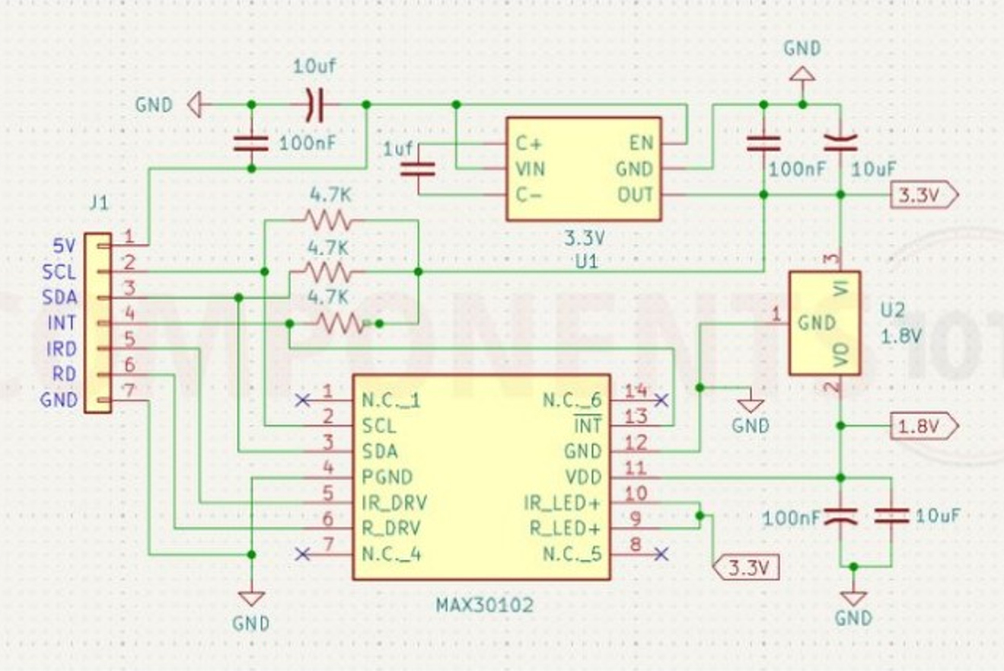
Figure 18: Max30102 sensor inner circuit schematic of inner structure [19].

5.2 Caregiver Response Time

Average caregiver response time to missed dose alerts was measured over the study period [18]:
- Without escalation: 45 minutes
- With escalation to alternate caregiver: 18 minutes

6. Clinical Reporting and Decision Support
Beyond real-time adherence monitoring and caregiver alerts, the proposed system incorporates a comprehensive reporting module that generates printable weekly and monthly summaries of patient health status. These reports consolidate medication adherence data alongside physiological measurements—including blood glucose, oxygen saturation, temperature, and blood pressure—into a structured format suitable for clinical review.
6.1 Report Generation
The mobile application generates PDF-based reports that can be printed directly or shared electronically with healthcare providers. Each report includes:
- Medication Adherence Summary: Percentage of doses taken on time, missed doses, late doses, and extra doses over the reporting period
- Vital Signs Trends: Time-series graphs of blood pressure, oxygen saturation, temperature, and glucose levels with timestamps correlated to medication events
- Correlation Analysis: Visual overlay of adherence patterns against physiological trends, enabling identification of potential relationships (e.g., missed insulin doses followed by elevated glucose readings)
- Inventory Status: Remaining medication quantities and expected refill dates
- Incident Log: Summary of alerts triggered, caregiver interventions, and escalation events
6.2 Clinical Utility
The reporting module serves multiple stakeholders:
- For Physicians: Reports provide objective adherence data and physiological trends, enabling evidence-based decisions regarding medication adjustments, dosage modifications, or alternative treatment strategies [20]. The correlation between adherence and vital signs offers insights into treatment effectiveness that are not typically available in standard clinical consultations.
- For Patients: Visual summaries help patients understand the relationship between medication adherence and their own health outcomes, potentially improving motivation and self-management behaviors [21].
- For Caregivers: Reports facilitate informed communication with healthcare providers, reducing the burden of manual data collection and recall-based reporting during clinical visits [22].
6.3 Analysis Framework
The system applies simple rule-based analysis to generate interpretive insights:
- Adherence Threshold Analysis: If adherence falls below a configurable threshold (e.g., 80%), the report highlights this as an area requiring clinical attention [23]
- Vital Signs Trending: The system flags readings that fall outside established safe ranges, aggregating these events to identify patterns over time [24]
- Medication-Outcome Correlation: The report visually aligns adherence timestamps with subsequent vital sign measurements, enabling clinicians to assess whether the prescribed regimen is achieving the desired physiological response [25]
6.4 Practical Implementation
Reports are generated through the companion mobile application and can be:
- Printed wirelessly from the app to any compatible printer
- Shared electronically via email or messaging platforms
- Integrated into electronic health records through secure data export (planned future enhancement)
This reporting capability transforms the system from a passive reminder device into an active clinical decision support tool, bridging the gap between home-based medication management and professional healthcare delivery.

7. Discussion
The proposed system makes several novel contributions to the field of home-based medication management. First, it introduces integrated multi-modal adherence verification, combining drawer opening detection with optional infrared-based pill removal confirmation. This hierarchical approach reduces false adherence reporting while maintaining cost efficiency, addressing a limitation of conventional systems that rely on single-point detection [7], [26].
Second, the system employs a cost-optimized modular architecture that separates core medication management functions from optional health monitoring features. This design achieves a base model cost under 100 USD while maintaining scalability, bridging a critical gap between low-end consumer devices and high-end clinical systems [8], [9].
Third, the system implements a comprehensive caregiver alert ecosystem with multi-channel notifications and escalation mechanisms. This enables caregiver-configurable thresholds and alternate contact routing, going beyond simple alerts to ensure reliable communication of missed doses and supply issues [27], [28].
Fourth, the integration of prescription digitization through optical character recognition simplifies setup by reducing manual schedule entry—a frequently overlooked barrier to adoption, particularly among elderly populations [29], [30].
Fifth, the optional time-stamped health-adherence correlation enables synchronization of medication intake with Bluetooth-connected physiological monitors. This provides caregivers with contextual insights without requiring predictive analytics [10], [31].
Sixth, the application-level counter feature provides an additional layer of adherence insight by comparing expected medication consumption against actual remaining quantities. This enables detection of discrepancies that may not be captured by drawer sensors alone, such as when a drawer is opened but no medication is taken or when multiple doses are taken from the same opening event.
Finally, the system prioritizes offline-first reliability, operating without continuous internet connectivity by storing events locally and synchronizing when connectivity is restored. This ensures dependable operation across diverse deployment environments [32].

8 Limitations
Despite its contributions, several limitations should be acknowledged:
- The system cannot directly confirm ingestion of medication, as it relies on indirect indicators such as drawer opening and IR-based pill removal [7]
- Bluetooth health sensor integration requires compatible devices owned by the user, which may limit accessibility for some populations [33]
- The preliminary evaluation had a small sample size (n=10) over a short duration, limiting statistical power
- SMS functionality adds recurring operational costs not reflected in hardware BOM [27]

9. Conclusion and Future Work
This paper presented a cost-effective smart medicine box designed to improve medication adherence through an integrated system of reminders, sensing, caregiver communication, and optional health monitoring. By combining embedded hardware with mobile and cloud technologies, the system achieves a balance between functionality, affordability, and scalability.
The proposed system introduces several advancements beyond existing solutions. First, it achieves household affordability through a modular architecture that separates core adherence functions from optional health monitoring, with a base model bill of materials under 20 USD. Second, it implements a hierarchical adherence verification mechanism that reduces false reporting while maintaining cost efficiency. Third, it integrates a multi-channel caregiver alert system with escalation capabilities, ensuring reliable communication of critical events. Fourth, it incorporates prescription digitization via optical character recognition to simplify setup—a feature absent in most consumer devices. Fifth, it supports time-stamped correlation between medication adherence and Bluetooth-enabled health monitoring, enabling contextual insights without predictive modeling. Sixth, it includes an application-based counter feature that compares expected versus actual medication quantities over time, revealing discrepancies that may indicate missed or extra doses. Finally, the system is designed for offline-first operation, ensuring reliability in environments with unstable internet connectivity.
Preliminary results demonstrate improved adherence rates and positive user acceptance, suggesting that the proposed system has strong potential for real-world deployment in chronic disease management scenarios. By addressing both functional and economic constraints, this work contributes a practical solution to a persistent healthcare challenge [4].
While the current implementation demonstrates promising results, several directions remain for future development. Larger-scale clinical validation with extended follow-up periods is necessary to establish statistical significance and generalizability across diverse patient populations [2]. Integration with electronic health records would enable seamless data sharing with healthcare providers, facilitating more coordinated care delivery [34]. Exploration of RFID-based medication identification could further automate inventory management by eliminating manual quantity entry and reducing user error [8]. Voice assistant integration would enhance accessibility for patients with limited dexterity or visual impairments, allowing verbal reminders and status inquiries. Finally, development of a pediatric version incorporating gamification elements could improve adherence in younger populations by making medication routines more engaging and reducing resistance to treatment.
Collectively, these future directions aim to extend the system's impact across broader clinical contexts and user populations while maintaining the core principles of affordability, reliability, and ease of use established in this work.

References
[1] World Health Organization. (2003). Adherence to Long-Term Therapies: Evidence for Action. Geneva: WHO Press.
[2] Sabaté, E. (2003). Adherence to long-term therapies: policy for action. WHO/MNC, 1–12.
[3] Osterberg, L., & Blaschke, T. (2005). Adherence to medication. New England Journal of Medicine, 353(5), 487–497.
[4] Cutler, R. L., et al. (2018). Economic impact of medication non-adherence: a systematic review. BMJ Open, 8(1), e016982.
[5] Brown, M. T., & Bussell, J. K. (2011). Medication adherence: WHO cares? Mayo Clinic Proceedings, 86(4), 304–314.
[6] DiMatteo, M. R. (2004). Variations in patients' adherence to medical recommendations: a quantitative review of 50 years of research. Medical Care, 42(3), 200–209.
[7] Aldeer, M., Javanmard, M., & Martin, R. P. (2018). A review of medication adherence monitoring technologies. Applied System Innovation, 1(2), 14.
[8] Kalantarian, H., et al. (2017). A survey of smart pill boxes and medication adherence monitoring systems. IEEE Transactions on Biomedical Engineering, 64(6), 1185–1196.
[9] Iuga, A. O., & McGuire, M. J. (2014). Adherence and health care costs. Risk Management and Healthcare Policy, 7, 35–44.
[10] Majumder, S., & Deen, M. J. (2019). Smartphone sensors for health monitoring and diagnosis. Sensors, 19(9), 2164.
[11] P. Fraga-Lamas, D. Barros, and S. I. Lopes, "The Role of ESP32 in Enabling Industry 4.0 and 5.0: A Comprehensive Narrative Review of Edge Intelligence, Human-Centric Automation, and Sustainable Innovation," IEEE Internet Things J., vol. 11, no. 11, pp. 19070–19093, 2024. [Online]. Available: https://www.preprints.org/manuscript/202508.0014.
[12] A. Author et al., "Enhanced Secure Blockchain-edge-internet of Things System for Real-time Healthcare Monitoring," Int. J. Intell. Eng. Syst., 2025. [Online]. Available: https://inass.org/wp-content/uploads/2025/08/2025113032.pdf.
[13] R. Al-Shammary, D. Mousa, and S. E. Esmaeili, "The design of a smart medicine box," in Proc. Iranian Conf. Electr. Eng. (ICEE), May 2018, pp. 130–134, doi: 10.1109/ICEE.2018.8472476.
[14] S. Author et al., "An IoT-Based Wireless Wearable Health Monitoring System Using ESP32 with Machine Learning-Driven Cloud Visualization," Int. J. Drug Deliv. Technol., vol. 16, 2025. [Online].Available: https://impactfactor.org/PDF/IJDDT/16/IJDDT,Vol16,Issue37s,Article17.pdf.
[15] Mistry, N., et al. (2015). A systematic review of the effectiveness of electronic medication management systems. Journal of Medical Systems, 39(2), 1–12.
[16] A. K. Katkoori, D. B. Prakash, R. Kumar M, A. S. Reddy, and G. P. Kumar, "FreeRTOS and IoT Based Smart Physiological Parameter Monitoring System," in 2026 IEEE International Conference on Intelligent Systems, Smart and Green Technologies (ICISSGT), 2026, pp. 1-5. [Online]. Available: https://api.semanticscholar.org/CorpusID:287965183.
[17] Analog Devices, "MAX30102: High-Sensitivity Pulse Oximeter and Heart-Rate Sensor for Wearable Health," Data Sheet, Rev. 1, Oct. 2018. [Online]. Available: https://www.analog.com/media/en/technical-documentation/data-sheets/max30102.pdf.
[18] IEEE, "Motion Artifact Reduction in Photoplethysmography for Reliable Signal Selection," in Proc. IEEE Eng. Med. Biol. Soc. (EMBC), 2021. [Online]. Available: https://www.paperhost.org/proceedings/embs/EMBC21/files/1756.pdf.
[19] “MAX30102 sensor oximeter and heart rate,” Components101. https://components101.com/sensors/max30102-sensor-oximeter-and-heart-rate-pinout-datasheet.

